Vanguard RFP:
eDiscovery.
Trustpoint.One – Proprietary & Confidential
July 29th, 2019
Presented By:
Kea Asato and Sylvia Yae
Assessment of Vanguard’s E-Discovery Requirements

With more than half of the litigation costs attributed to eDiscovery, it is increasingly vital that corporate counsel become more vigilant with controlling and predicting these costs. Trustpoint.One (TP1) has found that many of our corporate clients prefer to be more actively involved in planning, overseeing and monitoring their companies’ cases as part of a larger effort to reduce the time and cost of eDiscovery of their outside counsel. For many corporations that are actively facing continuing litigation and investigations, a myriad of solutions is often at their disposal that can handle each part of the eDiscovery phase, from collection, processing and hosting, review and productions.
The issue with utilizing different entities for each phase of eDiscovery is that it often leads to choke points that tend to slow down the process or create a need for complicated workaround solutions. Our aim is to remove these pain points and architect a workflow by becoming an e-discovery extension of your company in handling eDiscovery matters. With the assistance of our Discovery Consultant, Sylvia Yae, as direct liaison between outside counsel, Vanguard and our ESI team, we can focus on effective collaboration and accuracy in results.
As part of our continued vigilance and interest in data security, TP1 continues to be ISO27001 certified and our data security and data center are SOC Type II Certified. These standards are not easily obtained and keeping these certifications is one of the many ways that we exercise precaution and take a pro-active approach in keeping the data secure. We also employ a system of redundancies, back-ups and also physical security that includes locked down and gated key access, 24/7 video surveillance and fire-proof safes for any physical data that we receive from clients. TP1 has undergone rigorous security vetting through written and onsite auditing and instituted multi-factor authentication for all email traffic and share file servers. We have focused our service platform to Relativity, using our resources to provide bespoke solutions for our clients. Our team of experienced attorneys and technicians work with clients within the Relativity environment to script and design workflow that can manage small or large data sets to meet deadlines efficiently.

1. ESI: Collection/Processing/Hosting

In the past, TP1 generally has received data that has been provided directly by our clients or through a third party vendor in response to upcoming litigations or investigations. This has involved anything from emails to shared network drives, scanned hard copies, voice recordings, laptop, cellphone imaged data and social media accounts. While we no longer personally handle collections, we partner with Setec Investigations for most of our collections needs and will be able to work with you and Setec regarding the best defensible collection processes across the United States. As part of this process, we can provide personalized, case-specific forensic analysis and insight into your data. For any international data collections, TP1 can consult with Vanguard and the collection team regarding best practices for collecting and importing data given the numerous data privacy regulations across the world.
Our experienced team (mix of eDiscovery data analysts, tech specialists and attorneys) will work with the firm and client’s counsel to streamline the collection process, making sure to collect data that directly relates to the litigation or investigation request. We have often been able to assist in preventing multiple touch points on the same data and also avoid processing the same data multiple times.
After the data is collected, our ESI team works with the client and outside counsel through our Discovery Consultant and liaison, Sylvia Yae, to process it using Mindseye. TP1 can provide valuable reporting from timeline reports by custodian, keyword search term hit counts with uniqueness and exclusiveness, recipient and sender lists and file type reports. This aids in the culling of the data set and provides an additional frame of reference to adjust terms and re-evaluate custodians involved in the collection. TP1 provides access to this processing engine environment to the client and also a PM to guide your team with consultative advice.
In addition to validating the data set against the targeted data requests, the team is able to provide early insight into the data, and assist in only promoting into relativity the data that we would need for review. By doing this, we are able to reduce the cost of hosting and review on unnecessary data. Typically, we see clients promoting documents and their families that hit on search terms and by using global deduplication. Email threading can then be run in order to isolate only the unique content records. This is another step that can greatly reduce review timelines and costs. We can see a data reduction of anywhere between 40-90% of volume in this processing stage.

It’s a Partnership:
We have found that many of our clients prefer an active role in planning, overseeing and monitoring their cases as part of an effort to reduce the time and cost of eDiscovery.

2. ECA Analysis and Workflow Design

TP1 is uniquely positioned to work with firms as our team of ESI PMs and Discovery Consultants also consist of attorneys with background experience in working at AmLaw 100 firms. Providing you a point of contact with consultants with this experience puts us in a better position to be able to reduce costs by providing a richer set of data for review. Furthermore, our collective experience with numerous litigations and investigations gives us the ability to assess and implement workflows for review that take into consideration how the data was processed with an eye toward efficient review, automated production and seamless transitions into any required privilege and redaction logs.
After the data is promoted into relativity, our team creates the framework for review workflow including the creation of coding palettes, case tags, working with the firm closely for a more efficient review. Our experienced attorneys possess a varied background in litigation and investigation allowing us to devise numerous strategies to reduce the review population. Our goal is to provide the most accurate review without sacrificing efficiency by utilizing a number of tactics such as logos, signature block images and other repetitive file removal to shrink the data set quickly; native redaction workflows and duplication applications to only redact a document once; and search optimization to take general ideas into concrete document sets.
Our goal for our clients is reducing the data requiring "eyes on" linear attorney review, often achieved through the use of Predictive Coding and more generally through the various tools available under the rubric of Technology-Assisted Review (TAR). TP1 has a dedicated team of attorneys and technologists skilled and experienced in defensible data reduction. We have achieved data reductions in excess of 90% using various methodologies and tools, including most recently through the use of Relativity-Assisted Review (RAR). We also provide TAR through Sentio, giving clients another affordable option to reduce the review universe. We act under the direction and supervision of counsel, and all of our work is documented and fully transparent.
TP1 will work closely with you regarding assessing the use of predictive coding, multi-lingual documents, Relativity Analytics and AI. TP1 frequently receives data in a multitude of languages. Our Discovery Consultant, Sylvia Yae, has had years of experience working on a global FCPA investigation at an AmLaw 100 firm that spanned multiple countries and co-counsel in various countries for whom English is not a first language. After processing the documents through combined TP1 and first level review, she was able to determine the population of documents that spanned over a dozen languages by utilizing metadata fields and search strings of common foreign language text. The data was grouped into specific sets and a combination of machine and human translations was used to reduce the total spend.
As part of global FCPA investigations and other international litigations, Sylvia’s work with counsel brought to light many of the unique concerns regarding the differences of our data privacy rules in each region. While collecting the data was generally straightforward, many of the countries had specialized rules regarding transferring the data into the United States. In many instances, Sylvia and outside counsel worked with local counsel and other review teams to have the data reviewed in that country for proper redactions on either state secret information or personally identifiable information. To ensure best practices of future international data delivery across borders, Sylvia consults with outside counsel and the collections team regarding data handling and review prior to entering the United States.
TP1 has a strong team of developers and custom solutions architects that can deliver unique scripts and solutions to organize large data sets. Another example that illustrates our strength in this area is our ability to handle the privilege log process. We have a number of attorneys on our team that have worked on a number of privilege logs for clients. Generally, our Discovery Consultant, Sylvia, would work with counsel to determine the workflow of the data, automating the review process and providing a built in QC process to make sure that the correct set of documents populate the privilege and redact log review. In addition, additional measures are taken during the review process so that any ongoing review or production will not overlap the privilege log workflow. Creating an automated review/QC process allowed teams located in various time zones to keep the review moving forward without creating a choke point in the process. In addition, TP1 can shift the ESI team to provide hands-on 24/7 support for the client.

We typically employ a combination of the following methodologies to reduce data defensibly:
Use of an iterative process with stakeholders
Use of TAR/RAR to divide review set into ranked subsets for further analysis and review
Key Term Development, Searching, Testing and Validation
Consultative approach to setting data filtering parameters
Analysis of Hit Counts
Use of stemming reports and judicious use of wildcards
Pre-tagging of documents using responsiveness and privilege screens
Suppression of clearly irrelevant sender domains, irrelevant file types, file path
Email Threading to suppress lesser non-inclusive email threads to improve review accuracy and rate
Identification of document sets suitable for bulk coding
Validation of Null Set
Sample non-hits with variants of key terms, key custodians during defined time ranges
Use of Control Custodian(s)
All work product retained
Maintenance of archives for further analysis as needed
One point of contact,
multiple points of expertise:
As a provider of truly integrated legal solutions, with experience across a broad spectrum of matters, we provide our clients with a simplified experience, just one person call to matter what comes up.

3. Managed Review and Staffing

Costs of eDiscovery by Phase:
As part of our services, TP1 also offers managed and staffing review options that can be hosted at our review locations in Atlanta, Washington DC, New York City, Ohio, Pittsburgh and San Francisco Bay Area. TP1 provides exceptional quality, cost-effective, defensible managed review services for leading law firms and Fortune 500 corporations. Through focused expertise, responsiveness and reliability, TP1 continues to distinguish itself from traditional legal staffing agencies and large end-to-end consulting organizations. Our sole focus and core competence is managed document review. Led by lawyers with deep eDiscovery experience, we maximize defensibility and minimize cost through collaboration with our clients and the application of best practices and innovative solutions.

Once the total scope of the project is known, TP1 will suggest an initial team size for the review. This team will review for one to two weeks to determine review productivity rates and estimate completion. We will then add reviewers if necessary to achieve the client’s production goals. This approach streamlines the cost of review while delivering on-time completion. At the core of TP1’s success is our ability to scale up exceptional review teams and dedicated review centers at any time and in any location. TP1 routinely and quickly increases review team size when required.
We assume direct management oversight of our reviews. Our team leadership operates under the direction and supervision of counsel. The review managers are present with the team and are themselves involved in the review, typically compiling metrics and answering questions, but also directing and performing Quality Control. The review team is led by a full-time Project Manager who directly manages the review, performs QC, liaises with the Discovery Consultant and serves as TP1’s “eyes and ears” on the floor.
To optimize quality from the beginning, the TP1 Project Manager coordinates review team training at the beginning of each review. TP1 also compiles a coding manual with detailed coding rules, background material and a glossary of key terms for each review working in concert with the firm regarding the review protocol. The Coding Manual aids in training, review consistency, and the Quality Control process. The Project Manager maintains an Escalation log documenting all important decisions made by the client and outside counsel throughout the review. This provides both updated guidance to the review team, and an audit trail for defensibility. Our team also tracks review pace and measures productivity to ensure that deadlines are met. During the review, TP1 performs QC review to insure that the team is performing accurately, sending all inquiries to counsel. We collaborate with counsel to integrate TP1 QC process with the QC performed by outside counsel.
TP1 distinguishes itself from traditional legal staffing companies in a number of ways. Our recruiters are experienced attorneys who use proprietary technology to match outstanding candidates with the project requirements. TP1 personally interview candidates- verifying state bar admission and checking personal and professional references. TP1 reviewers execute written conflicts and confidentiality agreements. TP1 pays competitive rates and will run background checks upon client requests. Our review PMs focus exclusively on document review and will work with our Discovery Consultant and ESI PM to make sure that the right data set is being reviewed. A daily metrics progress report measuring progress will be sent to the client along with access to a custom TP1 dashboard in relativity. The dashboard will provide a visual progress report regarding the data, depicting graphs for date ranges, custodians, documents reviewed and produced, and also easily programmable to allow for additional information that may help Vanguard get a better view of the data.

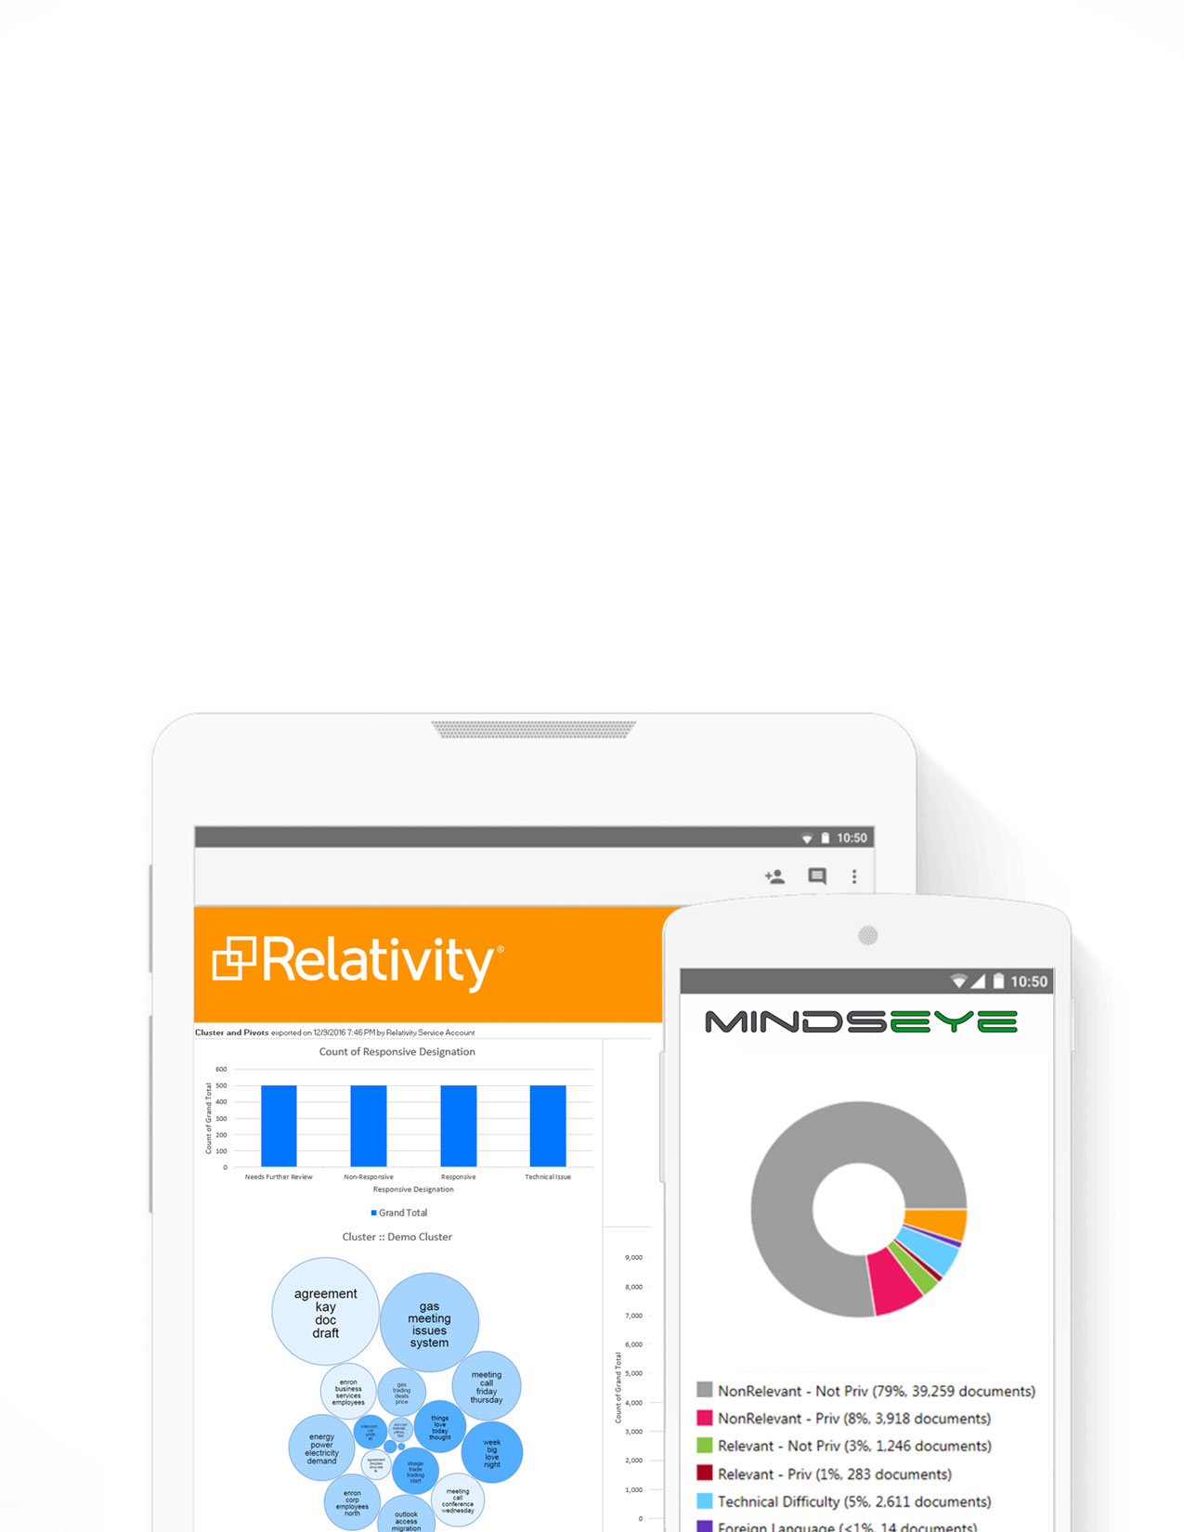
Be flexible:
One of the most important lessons that we have learned is that while many cases involve run of the mill productions, the ability to handle bespoke productions is paramount.

4. Productions and Post Review

The exponential increase of data that is being collected, reviewed and ultimately produced in litigation and regulatory investigations indicates that that there’s an unprecedented push in the amount of ESI that is being created and stored. TP1’s experience with our clients has shown similar indications that the future of eDiscovery supports this theory as well. We have streamlined our production process to be able to deliver consistent results and address any unique concerns a particular case may require. One of the important aspects of the eDiscovery process post review involves assisting outside counsel with production, depo prep, privilege and redaction logs.

While being actively involved in many of the productions with counsel, TP1 streamlined and customized multiple solutions to handle a variety of productions. One of the most important lessons that we have learned from this is that while many cases involve run of the mill productions, the requirement to handle bespoke productions is paramount. These requests are often time-consuming and without the ability and experience to handle this expediently, they can sometimes cause a delay in production delivery. Many of these instances require meta-data alterations (either adding or omitting), producing translations or embedded documents that require redactions and extra processing efforts, and unique confidentiality stamping, depending on the source of the data or the recipient. TP1’s experienced consultants are able to insure efficient production workflow by utilizing this information to assist our clients with helpful negotiations and insure proper collections

5. Additional Services

Court Reporting: We combine peerless technology with an always-reliable staff to deliver your transcripts on-time, every time and in any format you need them, globally. We choose our court reporters for their history of accuracy, customer experience and on-time delivery. Our next-level technology simplifies and streamlines the entire process. All Real-Time reporters carry the Certified Real-Time Reporter (CRR) credential. All videographers carry the Certified Legal Video Specialist (CLVS) credential. Transcripts match the video word-for-word, expression-by-expression. Search transcript and video together to easily make clips and export to TrialDirector, Sanction, PowerPoint or an E-Brief from our DVD with pre-loaded software. In many cases, we have worked with our key clients through the entire life-cycle of the case, from eDiscovery and hosting, through managed review including deposition prep, and have the ability to create the word index for our reporters to ensure that they understand the key words for your case. Having our reporters prepared prior to your depositions sets TP1 apart our competitors time and time again.

Translation Services: In addition to TP1’s eDiscovery and Managed Review offering, we also offer a translation service that provides a seamless process for managing foreign language content in cross border matters. In fact, TP1 is one of the only legal solution providers who have an in-house translation business, offering both machine and human translations. We offer machine translation (MT) both as a plug-in for our Relativity hosting platform and as an on-demand service.
TP1’s on-demand MT service is offered to any of our clients and does not require that the documents be hosted by us. In this case, documents that need to be translated would be sent to us and we will process them through our machine translation service which can then be returned to you for your review or to be hosted in another environment. Our human translation offering is supported by a global team of highly vetted translators and experienced project managers who provide 24x7 support. We have experience with large investigations, global disputes and various forms of cross border litigation.

5. Competitive Edge

To best serve Vanguard, TP1 has put together a team of professionals that have decades of experience working with law firms and corporate counsel to address your eDiscovery concerns. As part of this partnership, we expect to deliver solutions and work with you as an extension of your litigation/eDiscovery department. TP1’s team of tech specialists possess intimate working knowledge and experience with our tools to create bespoke solutions and workarounds to any problems that may arise. Our collective experience is vital to utilizing technology in a cost effective manner to achieve accurate results while providing cost predictability.
Our customized dashboard provides clients with on-demand data and cost information as well as an overview regarding your processed data and review progress. It is designed to give you a series of snap shots to provide a macroscopic visual analysis of the data, covering date ranges, custodians, search terms used, documents reviewed, produced, processed and associated costs. This provides you with accountability and an expectation regarding cost predictability.
As part of servicing other financial institutions, TP1 instituted rigorous security vetting and also multi-factor authentication for all email traffic and share file servers. Given the increasing number of corporate phishing attacks, we place a premium in ensuring that your data is secure. We also have worked with clients that require fast-paced, accurate reviews in response to data breaches to assist with providing timely notifications mandated by federal and state laws. These matters require a combined effort of teams and machines to meet deadlines and are examples of issues that we are able to handle on a daily basis.
Finally, TP1 is focused on consistent communication and receiving feedback from clients regarding our services. To insure that we continue to meet the needs of Vanguard, TP1 proposes a quarterly meeting between key members of Vanguard’s team as well as the TP1 team that will consist of Managing Directors, Kea Asato and Sylvia Yae, and members of the TP1 team that are vital to the process, such as Andrew Milauskas, Director of Operations of our ESI team. The meeting will focus on ongoing matters, future objectives, consultative insight on current matters, and implementation of any changes to improve workflow.
TP1 is committed to providing Vanguard with defensible, best practices in eDiscovery case management while offering you the ability to forecast costs and gain better insight into your data. Our team is uniquely qualified to handle any complications that may arise in the process through our ability to create unique workflow solutions. We look forward to being considered as part of Vanguard’s preferred vendor team by being an invaluable eDiscovery partner.

Thank You.
Kea Asanto & Sylvia Yea

