

**Proposal for Court Reporting Services**

z

March 6th, 2018  
  
Presented to: Alston & Bird Preferred Court Reporting Pricing Proposal for Imerys

**March 6th, 2018**

On behalf of the entire team at TrustPoint International, I would like to thank you for giving us the opportunity to propose our court reporting services for your consideration.

As one of the country’s fastest growing litigation management service providers, we look forward to establishing a long-term and productive relationship with your firm.

**Regards,**   
Jennifer Toner   
Title:   
E Mail Address:   
Mobile Number:

Presented By:   
John Wilkinson



**Table of Contents**

TrustPoint International Overview 1  
Summary of TPI Capabilities by EDRM Stage 2  
Court Reporting Service Offerings 3  
Video Services 3  
Benefits of Service 4  
Deposition Database & Repository. 4  
Implementation 6  
Pricing 7

**Trustpoint.One Overview**   
We’ve merged five leading legal and business service companies into one total, streamlined solution. So, no matter what comes up—from eDiscovery and Court Reporting to Legal Staffing, Translations and Managed Review—you get everything you need for the entire litigation lifecycle, all in one place, with one trusted partner. This is the Power of One™.



**Report.One**One complete deposition solution. Dispatch expert reporters anywhere you need them. Schedule online using our app and consider it done.

**Translate.One**  
Legal and Business translations solutions. We handle any type of content. We handle every market. No matter what you need, anywhere in the world.

**Discover.One**Game-changing eDiscovery solutions that actually makes sense. Enjoy flexible Custom and Managed Solutions™ with pricing and plans built just for you.

**Review.One**  
Blackletter.One and Partner.One set the standard in Legal Staffing and Managed Review. Discover what Review.One can do for you.

Presented By:   
John Wilkinson

**Court Reporting Service Offerings**Trustpoint is committed to provide only the highest quality in all our products and services.

**Court Reporting –** Committed to providing a network of thousands of experienced reporters, chosen for accuracy and on-time transcripts.

**National Coverage** – We will provide a dedicated toll free number. With one call, e-mail or fax, TrustPoint will provide court reporters in every venue and ZIP code in the United States.

**Fast Turnaround** - Transcripts are normally delivered within 10 business days. Expedited delivery is also available upon request.

Additional Services Include:

* Worldwide coverage, 24 hours a day
* On-line Scheduling, One Call Scheduling
* Interactive Real-time reporting
* Rough ASCII
* Special services for larger cases
* E-transcript
* Electronic transcript and exhibit archiving
* Electronic exhibits

Video Services

TrustPoint offers full legal video services worldwide for depositions.

* **Legal Proceedings** ─ TrustPoint offers full legal video services nationwide of all legal proceedings, i.e., depositions, statements under oath, mediation and settlement brochures, day-in-the-life documentaries, site inspections, etc.
* **Courtroom Playback** ─ TrustPoint provides operators, equipment and expertise for courtroom playback of previously prepared video.
* **Synchronized Digital Video** ─ with synchronized video, transcript text is synchronized to the videotaped testimony, an effect analogous to closed caption television. This means you may have instant access to any portion of video deposition testimony simply by searching for a keyword. Video segments may be predefined and played back in any order desired in a hearing, settlement conference or at trial.
* **Video Teleconferencing** ─ TrustPoint offers video teleconferencing centers in selected offices saving you time and travel costs. As members of national networks, we can arrange VTC services anywhere in the country and worldwide.
* **Foreign Language Services** ─ with one call to TrustPoint, you can arrange for qualified foreign language interpreters and/or translators wherever your deposition is located.

**Benefits of Service**

We assist our clients in evaluating new and efficient ways to reduce litigation expenses on an ongoing basis. We are committed to developing new techniques to control costs and improve service delivery while maintaining our high quality standards.

* **Continuity** – Having one team of reporters and one case manager who has complete familiarity with your case, the language, subject matter and a single point repository for all transcripts in the matter
* **Confidentiality** – Single Vendor relationship allows maximum security and control of documents and vital case information.
* **Value** – TrustPoint provides cost-efficient deposition and litigation services for all types of litigation anywhere in the world. Our competitive, consistent rates, determined by venue, help you manage deposition costs without sacrificing quality.
* **Quality** – Our Quality Assurance Program continuously monitors our court reporters and other service providers to ensure excellence no matter when or where you call upon us.
* **Services** – Our full range of services combines the latest technology with high-quality deposition services to support your litigation needs.
* **Facility** - We have 14 national convenient offices locally from Miami to California to New York.

Deposition Database & Repository

All deposition transcripts, synchronized videos, linked exhibits and documents will be stored in a secure, online, always-available repository.

Your online office includes five areas:

* **Job Calendar** – which displays your current and past schedule as a searchable list or monthly calendar. You can also access your calendar on your iPhone, BlackBerry or other web-enabled wireless device.
* **Smart Online Order Forms** – which make online requests easy because you only enter new information; they remember everything else. And requests appear on your job calendar as soon as you submit them.
* **Billing Information** – which includes your payment history, outstanding balances and detailed invoices.
* **Case Repository** – for sharing case-related files with co-counsels and anyone else helping you win a case.
* **Transcript-only Repository** – for quick access to downloadable transcripts of completed jobs.

Powerful Search Tools  
  
Search a terabyte of documents, exhibits, transcripts, and video depositions with powerful text search tools. All the contents are pre-indexed, so even complex searches are fast. The search result hits are highlighted within a few sentences of context and sorted by relevancy for easy screening. Advanced search options include fuzzy searches (for spelling and OCR errors), Boolean, synonym, homonym, advanced date recognition, numeric range, stemming, proximity, database fields, and variable-term weighting for hit relevancy. You can search by bates numbers, redaction attributes, or your own meta- data criteria.

**Secure**   
Your documents are uploaded, downloaded and viewed using secure, 128-bit encrypted web communications and hosted in our secure SOC 2 facility.

**Web Delivery of Transcript Files**   
Store, view, search and share your transcript and exhibit files easily – online with no worries about having the proper software or licenses. Transcripts are easily linked with PDF exhibits and then uploaded to your repository. Secure view-only delivery to full access delivery, you administer the rights.

**Web Delivery of Video Files**   
Store, view, edit and share your video easily – online with no worries about having the proper software or licenses.

**Modern Web 2.0 Implementation**   
The modern web interface is intuitive with drag-and-drop tools and no steep learning curves, is easy to customize, and provides familiar deposition management tools. The site is multi-platform, multi- browser compatible and designed for the way you work.

Online Content

**Depositions**   
View transcripts; view linked exhibits; issue code, annotate and highlight with online transcript management tools; all you need is web access.

**Video Depositions**   
View, highlight, edit and share high quality online synchronized video.

**Documents**   
View, highlight, mark-up, annotate or redact hundreds of document formats even without the application that created the original document.

**Discussion Forums**   
Organize your data and collaborate with others using online discussion forums including drag-and-drop tools to imbed hyperlinks to video deposition references, exhibit documents, edited video clips, and web links to other legal resources.

**Document Databases**   
Store and organize your document collections.

**Document Deposits**   
Communications of updates to individuals or groups. View document deposits and order document sets for complex litigation cases.

**Compatibility**   
Compatible with all the major computer operating systems (Vista, Windows 7, Windows 8, Apple's Mac OSX) and mobile devices (iPhones, iPads, Android, and Blackberries).

Trustpoint Reporting App Available

By going to the app store on your iPhone, Android, or BlackBerry; as well as iPad or other tablet, you can now download the Trustpoint app. Simply search Trustpoint Reporting within your device’s app store and download it – you will now have full time portable access to all transcripts and calendar of depositions wherever you have internet access on your device.

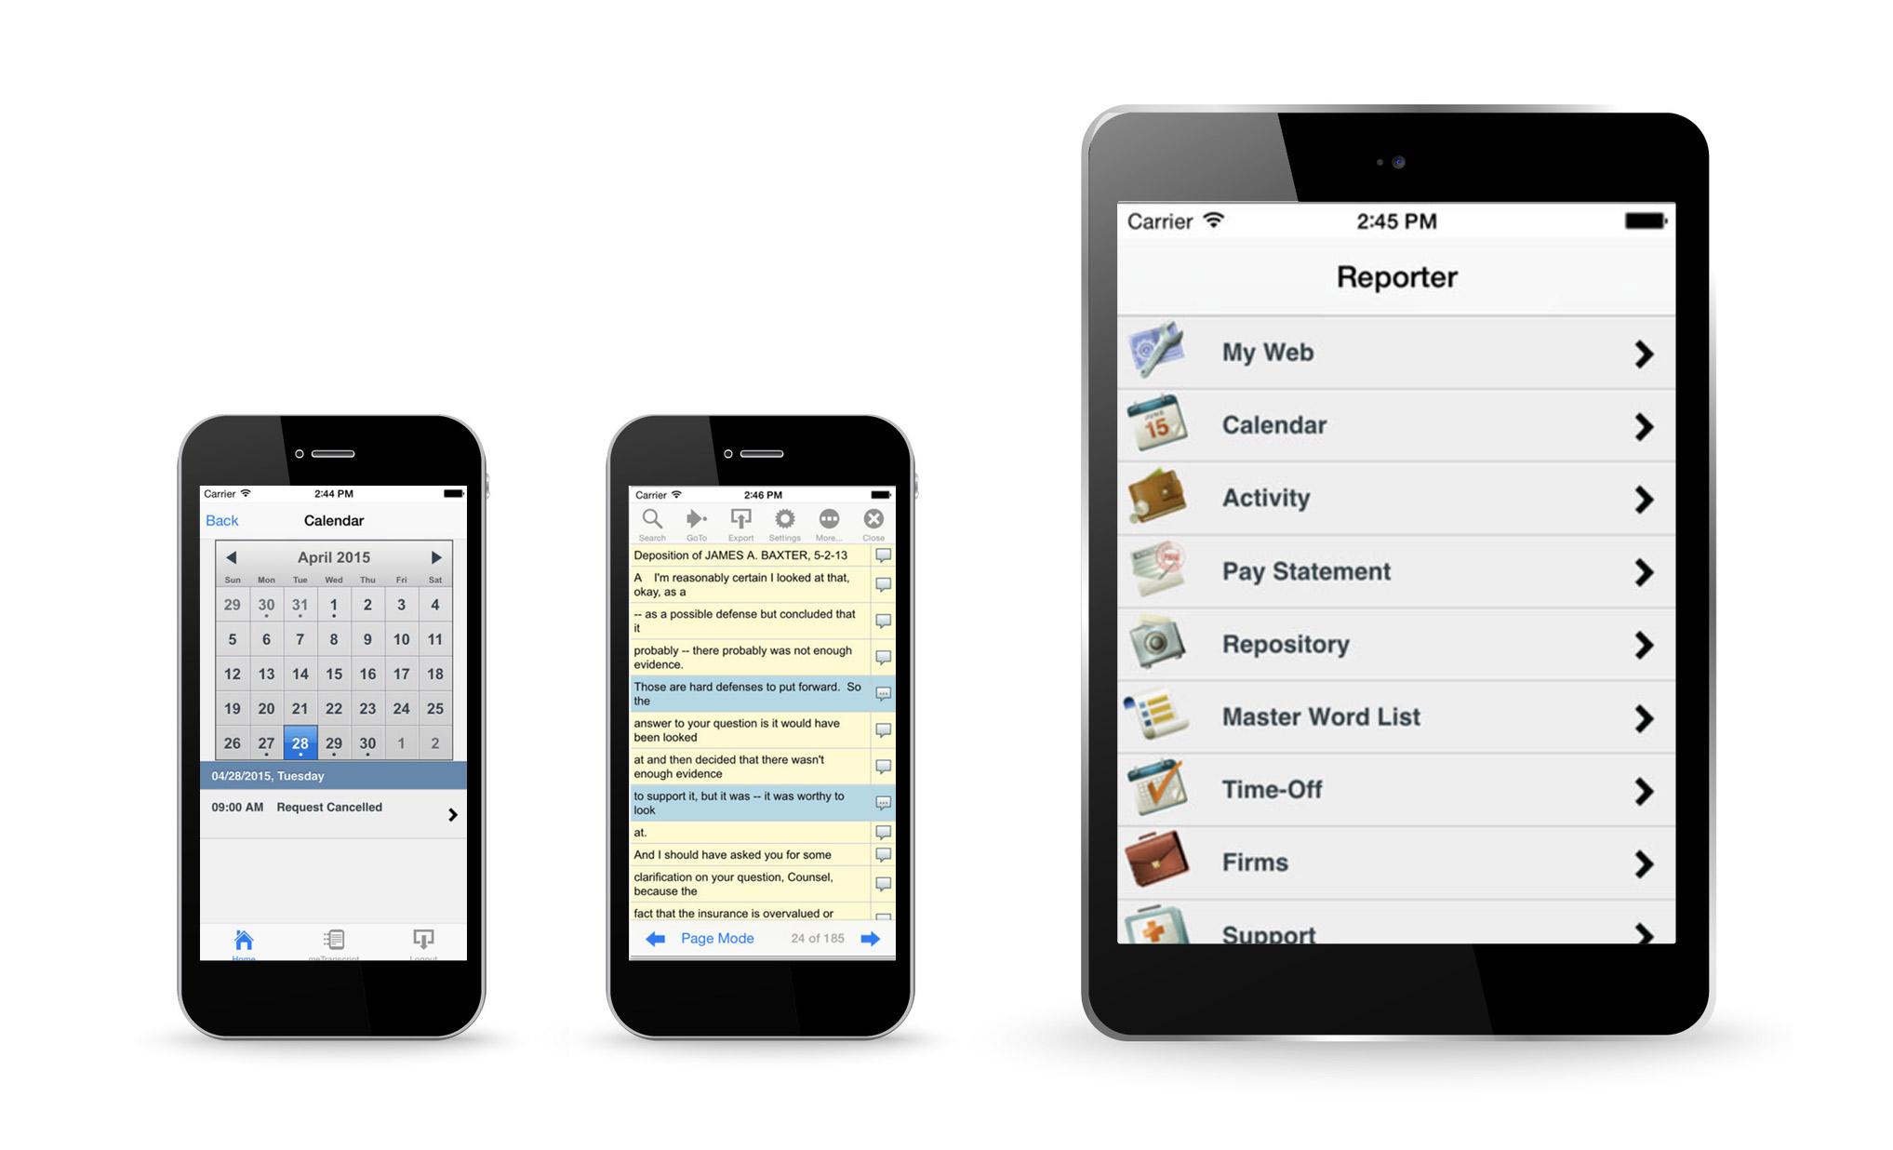

**Implementation**The TrustPoint Implementation Team will work diligently with Alston & Bird to draft a comprehensive plan to ensure protocols are met, to ensure accurate billing, to ensure adoption, and to ensure customer satisfaction.

The TrustPoint Implementation team with work in conjunction with your dedicated Project Management Team, which will include a dedicated, full-time, Account Manager. The team will be comprised of the following members:

1. Account Manager;

2. Case Manager;

3. Scheduling Coordinator;

4. Client Services Liaison; and

5. Billing Manager.

The dedicated Project Management Team will also be augmented by dedicated TrustPoint IT and billing departments, Client Services, and Operations.

**Pricing**

Pricing provided here is for general planning purposes and does not constitute a binding offer – pricing scenario based on multi-party litigation – pricing is subject to augmentation based on number of parties participating in litigation – our general assumption upon review is there are often multiple parties participating in the depositions – Important to note at 5+ participating parties the cost to Alston & Bird for page rate is $0.00 – all other rates are subject to decrease depending on other parties participation

The Barnes Law Firm

Deposition - California Pricing

|  |  |
| --- | --- |
| **Transcripts (Original and One Copy) – Northern California** | **Pricing** |
| 8 – 10 business days delivery (depositions) | $4.65 per page |
| **Transcripts (Original and One Copy) – Southern California** | **Pricing** |
| 8 – 10 business days delivery (depositions) | $4.90 per page |
| **Expedited Rates** | **(Add % to base page rate)** |
| Same day delivery | 100% |
| Next day delivery | 90% |
| 2 day delivery | 80% |
| 3 day delivery | 70% |
| 4 day delivery | 60% |
| 5 day delivery | 50% |
| 6 day delivery | 40% |
| 7 day delivery | 30% |
| Deposition Appearance Rates With Transcript Order – Northern California, two hour minimum  *(Monday - Friday, 8am - 5pm, excludes holidays)* | $55 per hour |
| Deposition Appearance Rates Without Transcript Order – Northern California  *(Monday - Friday, 8am - 5pm, excludes holidays)* | $375 half day & $565 full day |
| Deposition Appearance Rates With Transcript Order – Southern California  *(Monday - Friday, 8am - 5pm, excludes holidays)* | $No charge |
| Deposition Appearance Rates Without Transcript Order – Southern California  *(Monday - Friday, 8am - 5pm, excludes holidays)* | $400 half day & $735 full day |

|  |  |
| --- | --- |
| **Additional Services** | **Pricing** |
| Medical/Technical/Video/Telephonic Surcharge | $.50 per page |
| Interpreting Surcharge | $.50 per page |
| Real-Time* | $1.85 additional per page, per hook-up |
| Real-Time Streaming | $2.00 additional per page, per hook-up |
| Rough Draft* | $1.50 per page |
| Exhibits - Black/White or Color | $.35 per page |
| Original Transcript Handling Fee | $10 per transcript |
| Video (includes set-up, break down, & first hour of video) | $300 flat fee |
| Video Additional Hours | $125 per hour |
| Video DVD | $10 per DVD |
| Video Sync | $35 per video hour |
| Reporter Late Cancellation (if cancelled after 5pm the day prior) | $285 flat fee |
| Video Late Cancellation (if cancelled after 5pm the day prior) | $300 flat fee |
| Remote Conferencing - **Participant Set-Up** | $125 per participant |
| Remote Conferencing - **Live Stream Feed & Tech Support** | $50 per hour |
| Equipment Rental (Live litigation or Real-Time devices) | Complimentary |
| Litigation Support Drive | Complimentary |
| Read & Sign Handling | $10 per witness |
| Mini Transcript (with full size transcript order) | $10.00 per witness |
| Certificate of Non Appearance | $250 flat fee |
| Electronic Delivery | Complimentary with a hard copy purchase. Otherwise $15 flat fee |
| File Back-up & Hosting Services  (includes all videos, exhibits, and transcripts) | Complimentary |

**\* Please note: Any orders for Rough Drafts or Real-Time constitute a final transcript order**



**Get in Touch.**   
John Doe Contact  
800.555.1212  
jdoe@trustpoint.one