Critical Content into All Languages of the World.
Three Gateway Center, Floor 14W, Pittsburgh, PA 15222 | Trustpoint.One

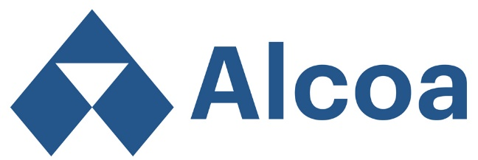

Helping Alcoa manage global business communications since 1984, Trustpoint.One (formerly Echo International) provides comprehensive multilingual translation and localization services.

Alcoa current and recent projects include:
Alcoa Foundation Projects, Alcoa Monthly Newsletter, Alcoa Updates, Alcoa Wellness, Health and Safety Projects, Anti-Corruption Training, Business Conduct Survey, Chairman’s/CEO Letters, Code of Conduct, Integrity Poster, Global Voices Project, SDS, HR System Translations…and much more.

Contact Information
Account Manager: Wendy Ruano
wendy.ruano@trustpoint.one | +1.412.314.4488

Working Successfully with Trustpoint.One:

Sending Files for a Quote or Project
- You can email files up to 25MB directly to alcoa@trustpoint.one.
- Alternatively, we can provide you with access to our client portal to facilitate file transfer.

Additional Request Information
- Send native files whenever possible. If you are sending PDFs, images, embedded text—essentially anything non-editable—let us know if the native files will be available at a later date.
- Provide a list of languages—and in the case of Spanish, French, Portuguese, and Chinese, provide the locale (Spain vs. Latin America, etc.).
- Provide a desired deadline if you have one; otherwise, we will quote using standard turnaround.

Quoting
- Once we have analyzed the files, we will send a quote within 24 hours unless otherwise agreed.
- When you approve the quote, send the PO or cost center number for the project.

In-Country Review Recommendations
- Identify a stakeholder for each language to review and sign off on the translation.
- In-country review ensures the translation will be acceptable to your target markets.

Our process includes the following steps:

We look forward to working with you.
Revised 04.06.2018

